

QIS College of Engineering and Technology

(Autonomous)

Directorate of Project Skilling and Research

Project Datasheet
Project Title | Smart Traffic Light Management System
Batch Number | 5
Domain | AI
Mentor Name | Dr.M.Guna

Mentor Signature

Abstract
The Smart Traffic Light Management System aims to optimize urban traffic flow by dynamically controlling traffic signals using Internet of Things (IoT), and real-time sensor data. Conventional traffic light systems follow fixed time intervals, often leading to congestion, long waiting times, and unnecessary fuel consumption. The proposed system integrates sensors, cameras, and machine learning algorithms to monitor vehicle density, prioritize emergency vehicles, and adjust signal timings accordingly. By implementing adaptive traffic control, the system reduces congestion, improves road safety, lowers carbon emissions, and ensures efficient use of road infrastructure. Anticipated results include smoother traffic flow, reduced travel time, and enhanced emergency response. This project has real-world applications in smart cities and urban mobility solutions.
Keywords: Smart city, Traffic optimization, IoT, Real-time processing, Intelligent transport systems.

Objectives
1.Develop an intelligent traffic signal control system to manage vehicle flow dynamically.
2.Reduce congestion, waiting time, and pollution by optimizing signal intervals.
3.Provide emergency vehicle prioritization for faster response times.
4.Integrate real-time data from sensors and cameras for adaptive decision-making.
5.Contribute to smart city initiatives by improving urban mobility.

Block Diagram

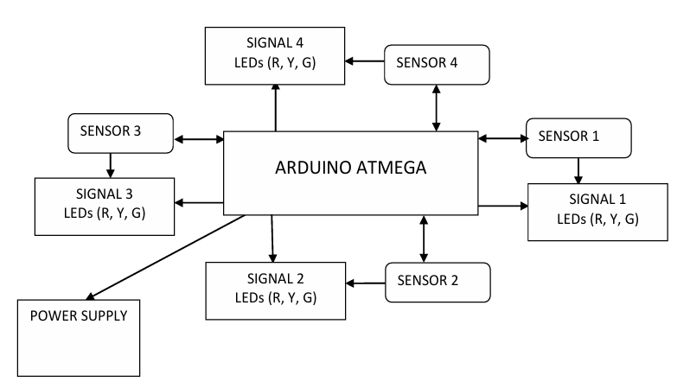

3D Diagram of the proposed prototype

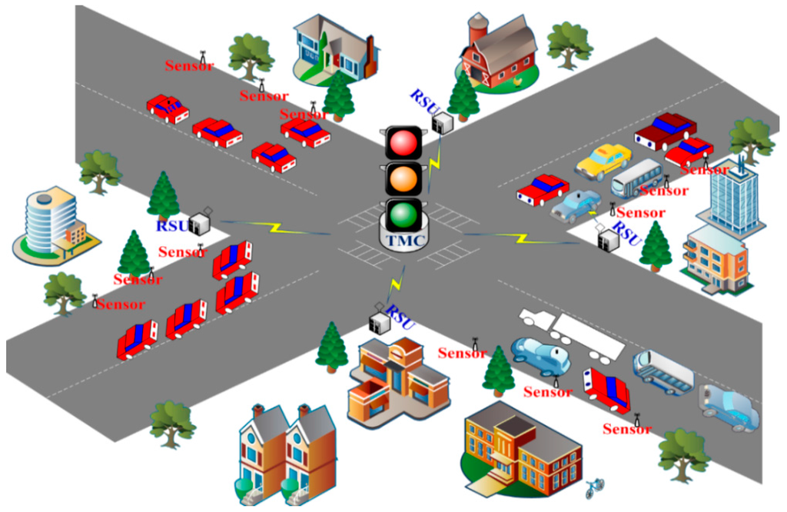

Functional Layout of the Project
Functional Layout of Smart Traffic Light Management System
Input Module: Data Acquisition
Function: Collects real-time vehicle count and density.
Components: IR sensors, IoT devices.
Tools: Arduino/Raspberry Pi, Python, OpenCV.
Preprocessing Module
Function: Cleans and formats raw data for analysis.
Components: Image preprocessing, sensor calibration.
Tools: OpenCV, Python.
Traffic Analysis & Decision Module
Function: Uses AI algorithms to determine optimal signal timing.
Components: Machine learning models, rule-based logic.
Tools: Python, TensorFlow, CVXPY (for optimization).
Control Module
Function: Adjusts traffic signal timings dynamically.
Components: Microcontroller interfacing with traffic lights.
Tools: Arduino/Raspberry Pi.
Output Module: Signal Display
Function: Displays optimized traffic signal sequence.
Components: Traffic light system, user dashboard.
Tools: Web app/Android app for monitoring.
Integration & Monitoring Module
Function: Provides centralized control and visualization.
Components: Cloud integration, dashboard, data logging.
Tools: Flask/Django, AWS, MQTT.

Functional Flow
1.Sensors/cameras capture real-time traffic data.
2.Data is preprocessed and sent to the controller.
3.AI algorithms analyze congestion and decide signal timings.
4.Controller updates traffic lights accordingly.
5.System monitors and logs performance for further optimization.

